EXP 7.1

NAME: RAMA SUBRAMANIYAN.V
REG.NO: 192419051
COURSE CODE: ECA0910
COURSE NAME: DIGITAL SIGNAL PROCESSING
PRACTICAL LAB RESULTS

CODE:

n=0.3*randn(size(t));
x=s+n;
figure, plot(x), grid on
title('Signal with Noise')
figure, periodogram(x,[],[],fs)
title('PSD using Periodogram')
figure
X=abs(fft(x));
f=(0:length(X)-1)*fs/length(X);
plot(f(1:500),X(1:500)), grid on
title('Magnitude Spectrum')
figure
bar([mean(s.^2) var(n)])
set(gca,'XTickLabel',{'Signal','Noise'})
title('Power Comparison')
grid on

OUTPUT:
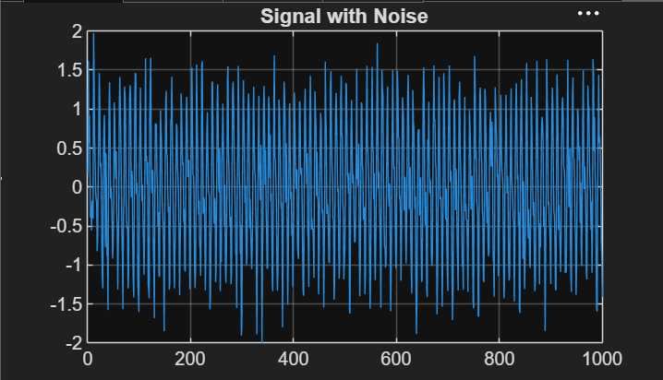

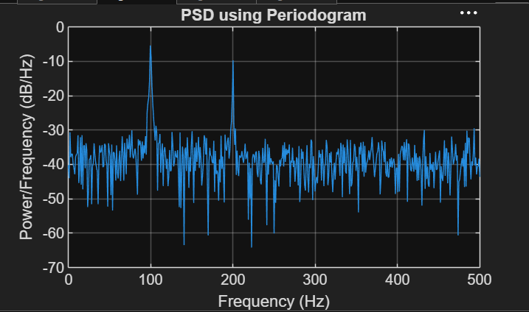

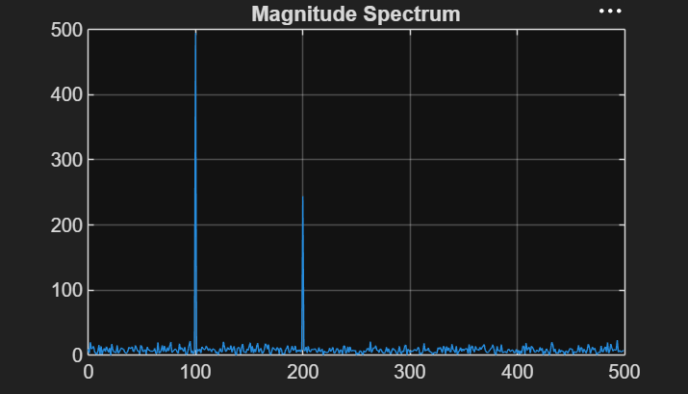

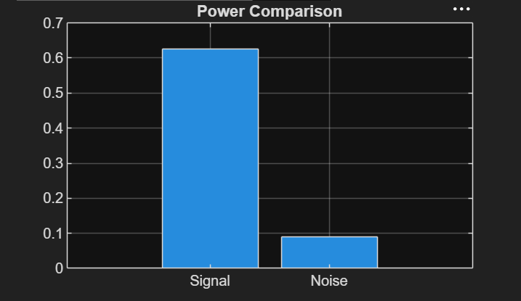

EXP 7.2

CODE:

clc; clear; close all;
% Signal
fs = 1000; N = 256; t = (0:N-1)/fs;
x = sin(2*pi*100*t) + 0.8*sin(2*pi*110*t);
NFFT = 2048; f = (0:NFFT/2-1)*(fs/NFFT);
% Windows
w = {rectwin(N), hamming(N), hann(N)};
names = {'Rectangular','Hamming','Hanning'};
% Processing
for i = 1:3
xw = x(:).*w{i};
X = fft(xw,NFFT);
P{i} = abs(X(1:NFFT/2));
P{i} = P{i}/max(P{i});
end
%% Individual Spectrums
figure;
for i = 1:3
subplot(3,1,i);
plot(f,20*log10(P{i}),'LineWidth',1.5);
title(['Spectrum using ' names{i} ' Window']);
xlim([0 250]); grid on;
end
%% Comparison
figure;
plot(f,20*log10(P{1}),'k',f,20*log10(P{2}),'r',f,20*log10(P{3}),'b','LineWidth',1.5);
legend(names); title('Window Comparison'); xlim([50 170]); grid on;
%% Window Shapes
figure;
for i = 1:3
subplot(3,1,i); plot(w{i},'LineWidth',1.5);
title([names{i} ' Window']); grid on;
end
%% Peak Detection
for i = 1:3
[pks{i},loc{i}] = findpeaks(P{i},f,'MinPeakHeight',0.3);
fprintf('\n%s Window Frequencies:\n',names{i});
disp(loc{i});
end
%% Peak Marking (Hamming)
figure;
plot(f,20*log10(P{2}),'LineWidth',1.5); hold on;
plot(loc{2},20*log10(pks{2}),'ro','MarkerFaceColor','r');
title('Detected Frequencies (Hamming)'); xlim([50 170]); grid on;
%% Main Peaks
fprintf('\nMain Spectral Peaks:\n');
for i = 1:3
[~,idx] = max(P{i});
fprintf('%s Window Peak = %.2f Hz\n',names{i},f(idx));
end

OUTPUT:

Rectangular Window Frequencies:
100.0977 109.8633

Hamming Window Frequencies:
100.0977 109.8633

Hanning Window Frequencies:
100.0977 109.8633

Main Spectral Peaks:
Rectangular Window Peak = 100.10 Hz
Hamming Window Peak = 100.10 Hz
Hanning Window Peak = 100.10 Hz
>>
